**Week 1**

**Question 1**

Read Alberto Cairo’s work, [Graphics Lies, Misleading Visuals](http://infovis.fh-potsdam.de/readings/Cairo2015.pdf)

Locate an example of a misleading visual that uses one or more of the mechanisms for misleading that Cairo outlines in his book chapter: (1) Hiding relevant data; (2) Displaying too much data and obscuring reality; (3) Distorting data through visual forms.

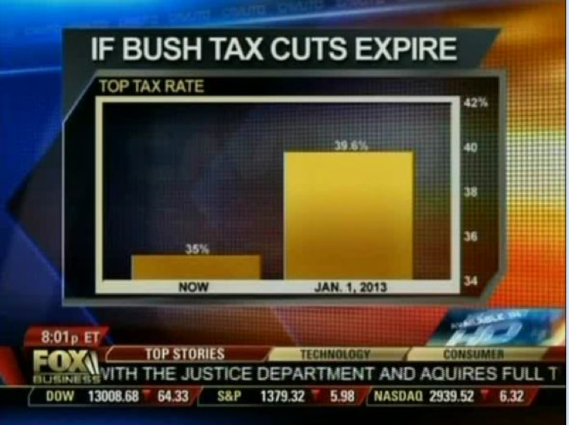

**Question 2**

Briefly describe the context for the visual by addressing the following questions:

1. What is the source of the visual? (e.g., URL or bibliographic citation)
2. Who is the intended audience (i.e., decoders)? How do you know this?

1. Source: https://www.mediamatters.org/fox-business/dishonest-fox-chart-bush-tax-cut-edition

2. People who watch the news in order to inform themselves. It is a graphic from fox news so you can know the decoder.

**Question 3**

1. Identify the specific component(s) of the visual that is/are misleading
2. For each part(s) of the visualization that is/are misleading, identify the mechanism that is used: hiding relevant data to highlight what benefits us; displaying too much data to obscure reality; using graphic forms in inappropriate ways (distorting the data)
3. Explain how the mechanisms are used to mislead

The specific misleading element is that it omits the baseline, that is, it does not start from scratch and distorts the perception. One of the bars looks as if it were 4 times the other being that there is a small difference in their values. In conclusion, what it did do was exaggerate the small difference that existed between the two values, since it was only small.